Java application with CICD

CI:
- Build agent
CI workload
- Git
- Java JDK
- Maven
- Docker
- Gitleaks
- Trivy
- SonarQube scanner integration
- Ansible agent
CD workload
- Ansible
- community.docker collection
- SSH private key / access to production
- inventory.ini and deploy.yml
- Production server
- Docker Engine
- Java application container
- Application port 8080

CICD FLOW:
- How the final pipeline behaves
- Normal deployment — DEPLOY / v4
- Checkout code from GitHub
- Gitleaks secret scanning
- Maven build and JUnit testing
- JaCoCo coverage report generation
- SpotBugs SAST
- OWASP dependency scanning
- SonarQube analysis and quality gate
- Docker build and Trivy image scanning
- Push Docker image v4 to Docker Hub
- Ansible deploys v4 and performs smoke tests
- Manual rollback — ROLLBACK / v3
- Skip checkout and all CI stages
- Ansible connects to production
- Deploys the existing Docker image v3
- Performs health and smoke checks
- Automatic rollback
- Ansible captures the current production image
- Deploys the requested new image
- Health or smoke check fails
- Ansible restores the captured previous image

Create a Build agent :
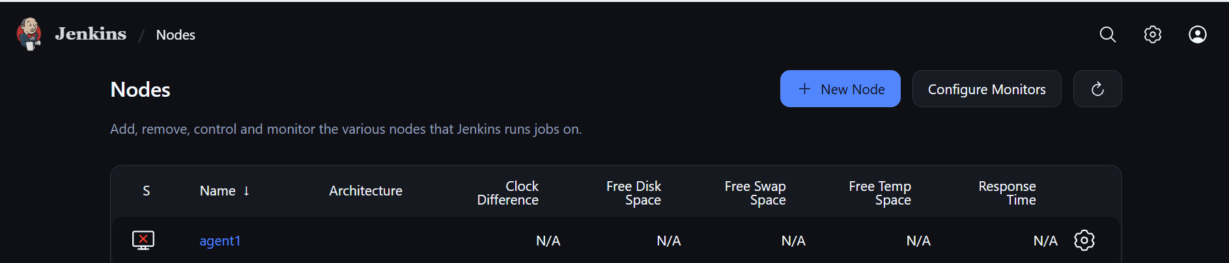

Run agent script in agent machine:
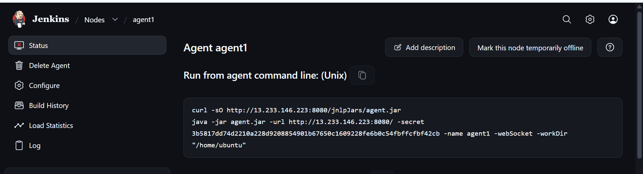
Insatll openjdk in agent machine and run:
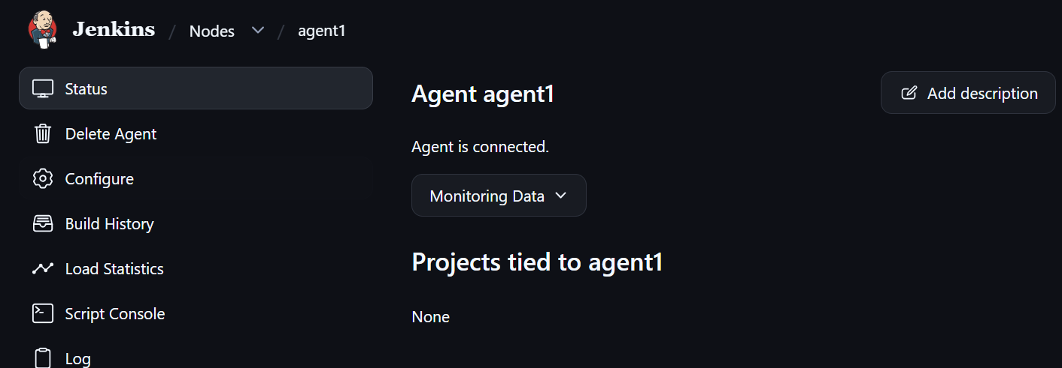

To run pipeline as docker agent :
Install the req plugins
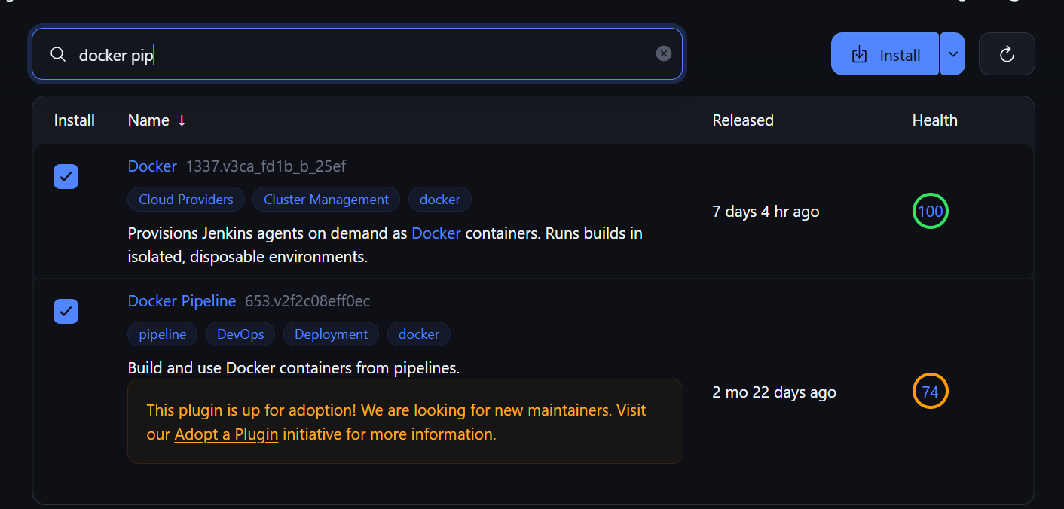

- You can keep your build agent VM relatively clean.
- Component | - Where
- Docker Engine | - Build agent VM
- Maven + Java 17 | - Temporary Maven container
- Gitleaks | - Dedicated container
- SonarQube | - Separate server/container
- Trivy | - Dedicated container or agent CLI
- OWASP | - Maven container
- SpotBugs | - Maven container
- Playwright | - Dedicated browser container later

Spotbug:
- SpotBugs — Static Application Security Testing
Use existing Maven container
SpotBugs analyses Java bytecode and looks for potential programming bugs.
You've already configured the plugin in your pom.xml:
<plugin>
<groupId>com.github.spotbugs</groupId>
<artifactId>spotbugs-maven-plugin</artifactId>
<version>4.9.3.0</version>
<configuration>
<effort>Max</effort>
<threshold>Low</threshold>
</configuration>
</plugin>

- mvn spotbugs:check
- What happens?
- Maven compiles your Java application.
- SpotBugs analyses the generated bytecode.
- It checks for suspicious coding patterns.
- It fails the Maven goal if findings meet the configured threshold.

OWASP:
- OWASP Dependency-Check — Software Composition Analysis
Use existing Maven container
- This checks your third-party dependencies for known vulnerabilities.
- For example, your project uses:
- Spring Boot
- Spring Web
- Jackson
- Other Maven libraries
- OWASP checks their versions against known vulnerability information.
- You already configured its Maven plugin.
- Run:
- mvn org.owasp:dependency-check-maven:check

Jacoco:
- JaCoCo — Code Coverage
Already configured in your POM
- JaCoCo measures how much of your Java code is executed by tests.
- For example:
- Suppose your IncidentService.java has 100 executable lines.
- Tests execute 80 lines.
- 20 lines are never executed.
- Your line coverage is 80%.
- You already configured JaCoCo in pom.xml, so you don't need to install anything else.
- Run:
- mvn clean verify
- The report is generated here:
- target/site/jacoco/index.html
- Install the HTML Publisher plugin.
- Then add this stage:
- stage('Publish JaCoCo Report') {
- steps {
- publishHTML(target: [
- reportDir: 'target/site/jacoco',
- reportFiles: 'index.html',
- reportName: 'JaCoCo Coverage Report',
- keepAll: true,
- alwaysLinkToLastBuild: true,
- allowMissing: false
- ])
- }
- }

SONARQUBE:
- Install Java 21 and PostgreSQL
SSH into the SonarQube VM:
sudo apt update

sudo apt install -y \
openjdk-21-jdk \
postgresql \
postgresql-contrib \
unzip \
wget
- Configure PostgreSQL
Start PostgreSQL:
sudo systemctl enable --now postgresql
- sudo -u postgres psql
- Execute:
- CREATE USER sonar WITH ENCRYPTED PASSWORD 'ReplaceWithAStrongPassword';

- CREATE DATABASE sonarqube OWNER sonar;

- \q
- Configure Linux kernel settings
SonarQube uses Elasticsearch. Configure the host settings before starting it.
sudo tee /etc/sysctl.d/99-sonarqube.conf <<'EOF'
vm.max_map_count=524288
fs.file-max=131072
EOF
- Apply:
- sudo sysctl --system
- Verify:
- sysctl vm.max_map_count
- sysctl fs.file-max
Download sonarqube zip file
Extract it:
sudo unzip sonarqube*.zip -d /opt/
Find the extracted directory:
ls -d /opt/sonarqube*
Assume the extracted directory is /opt/sonarqube-<version>.
Create a stable symlink, replacing the placeholder with the actual directory name:
sudo ln -s /opt/sonarqube-<version> /opt/sonarqube
- Step 6. Create a dedicated Linux user
SonarQube should not run as root.
sudo useradd --system --create-home --shell /bin/bash sonar
Set ownership:
sudo chown -R sonar:sonar /opt/sonarqube
The official installation guidance recommends a dedicated non-root account.
Sonar Documentation+1
- Step 7. Configure the database connection
Open:
sudo nano /opt/sonarqube/conf/sonar.properties
Set the following properties, replacing the password with the one you created in PostgreSQL:
sonar.jdbc.username=sonar
sonar.jdbc.password=ReplaceWithAStrongPassword
sonar.jdbc.url=jdbc:postgresql://127.0.0.1:5432/sonarqube

sonar.web.host=0.0.0.0
sonar.web.port=9000
Save the file.
Set ownership again:
sudo chown -R sonar:sonar /opt/sonarqube
- Step 8. Configure the systemd service
Create:
sudo nano /etc/systemd/system/sonarqube.service
Paste:
[Unit]
Description=SonarQube Community Build
After=network.target postgresql.service
Requires=postgresql.service

[Service]
Type=forking
User=sonar
Group=sonar
WorkingDirectory=/home/ubuntu/sonarqube/sonarqube-26.10.0.133078/

ExecStart=/home/ubuntu/sonarqube/sonarqube-26.10.0.133078/bin/linux-x86-64/sonar.sh start
ExecStop=/home/ubuntu/sonarqube/sonarqube-26.10.0.133078/bin/linux-x86-64/sonar.sh stop

LimitNOFILE=131072
LimitNPROC=8192

Restart=on-failure
RestartSec=10

[Install]
WantedBy=multi-user.target
Reload systemd:
sudo systemctl daemon-reload
Enable and start:
sudo systemctl enable sonarqube
sudo systemctl start sonarqube
Check:
sudo systemctl status sonarqube
- Then access SonarQube through your allowed network:
- http://<SONARQUBE-IP>:9000
- Initial credentials:
- Username: admin
- Password: admin
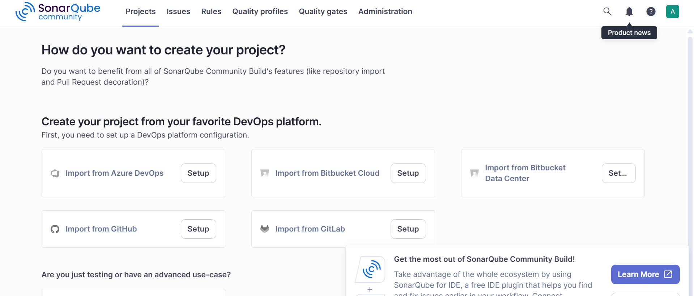

Create a project :
name

Sonarqube secret :

Give local analyses and give name and generate the token

In Jenkins
Add credential add on global system --> paste the secret and name

Now add sonar url in Jenkins:
Go to tools-->system in sonaqube section add the cred of sonar and name and url of sonar qube with priv ip

Setup ansible server:
Update the os
Install pipx
Instal ansible-core $ pipx install ansible-core
Install java

Make it has Jenkins agent

Setup the passwordless for prod server with ansible:

ssh-copy-id -f "-o IdentityFile pathofpemofprod" prod@ip

Prod-server:
Ready with Jenkins file and ansible plays books for deploy.yml and rollback.yml

Create a pipeline in Jenkins
Use pipeline and add trigger of 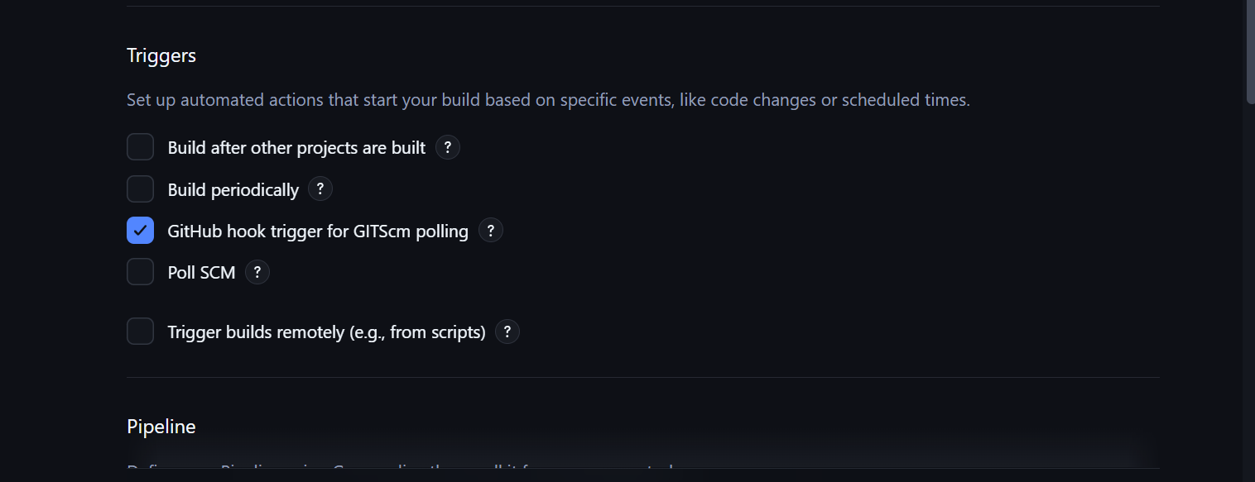
And add git scm repo
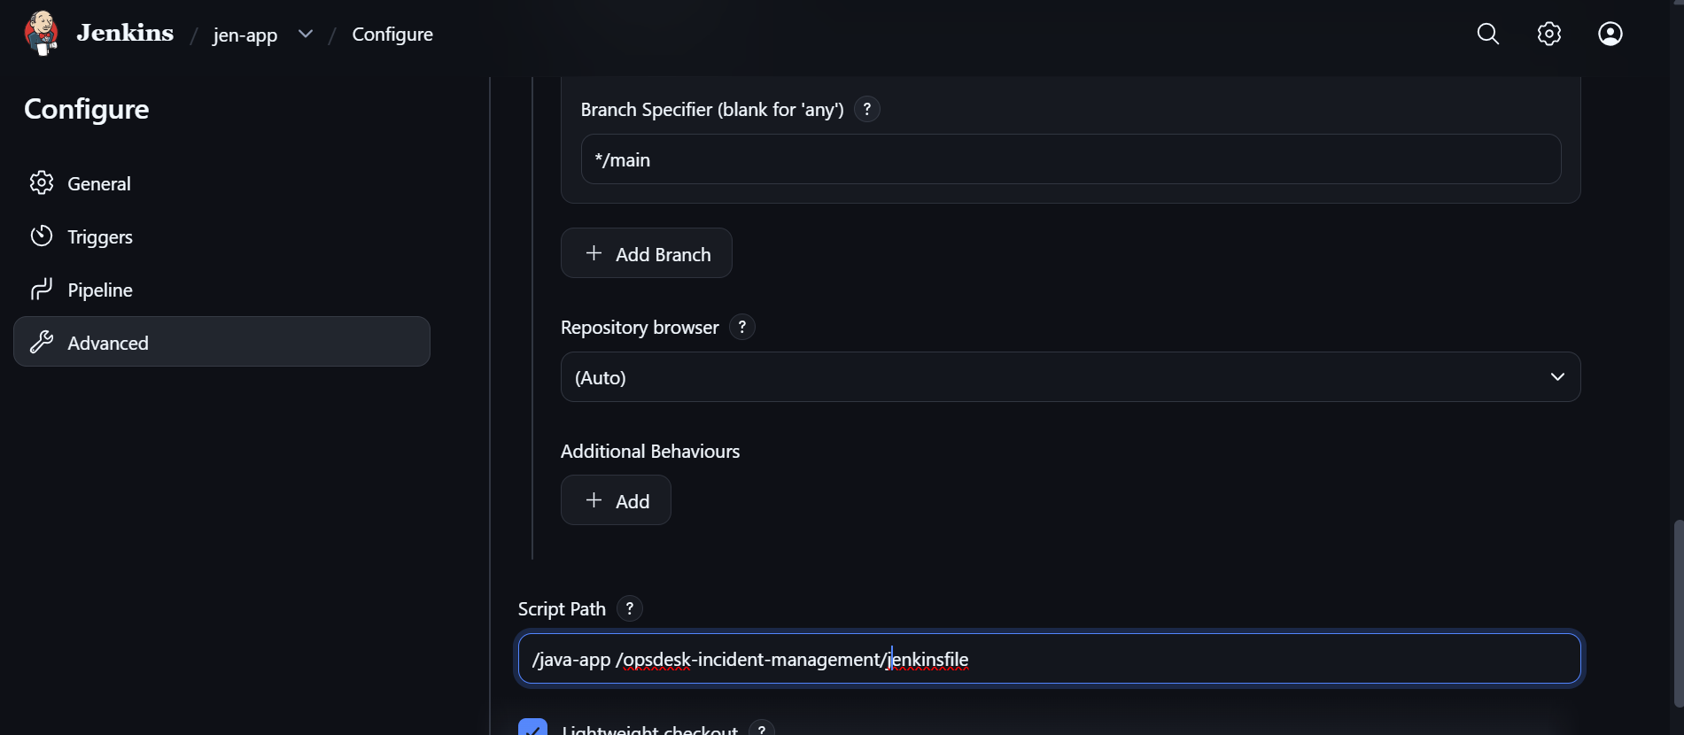
Create webhook with Jenkins in git

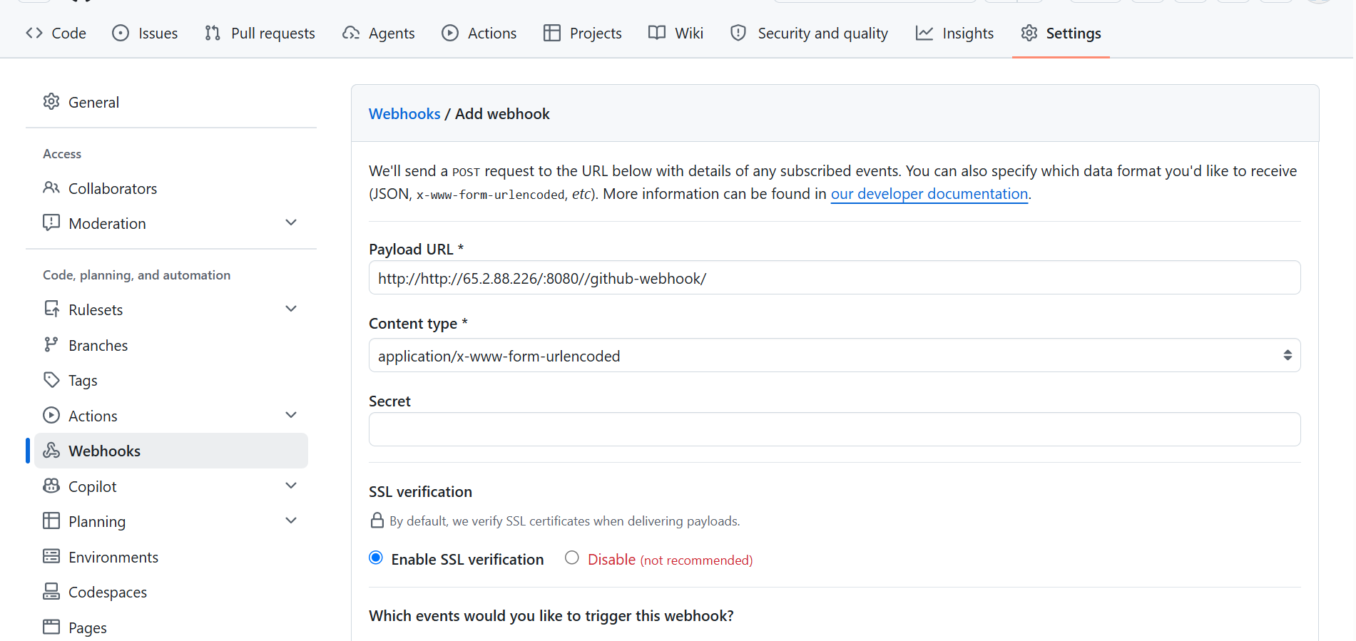

Git huh structure:
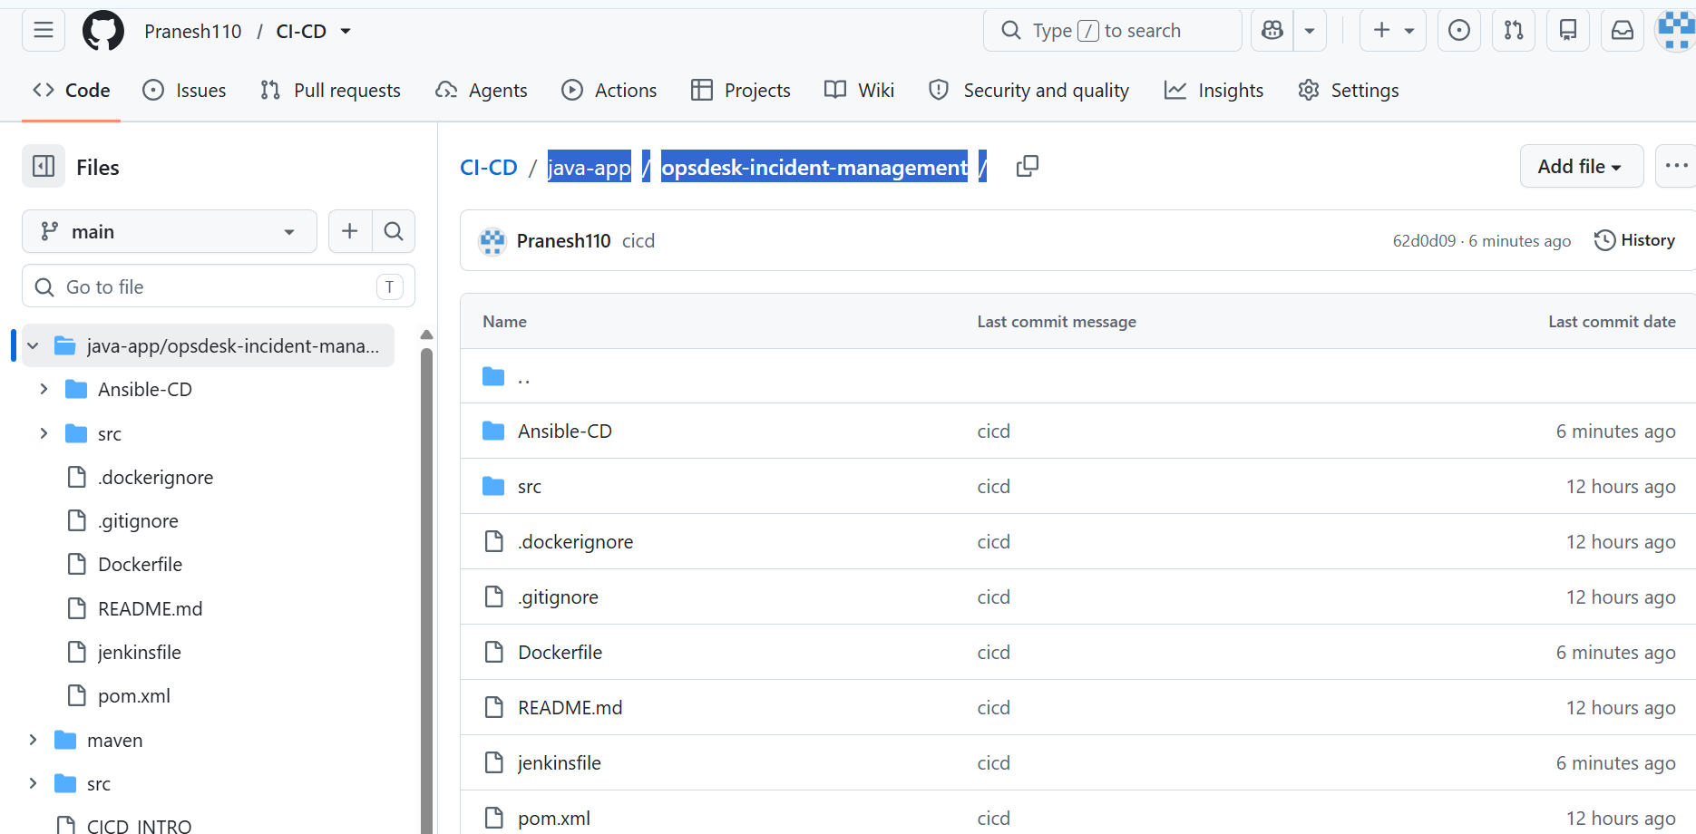

Run the pipeline manually or trigger will happen when push event occur:
Whn merge happen pipeling is trriger automatically:
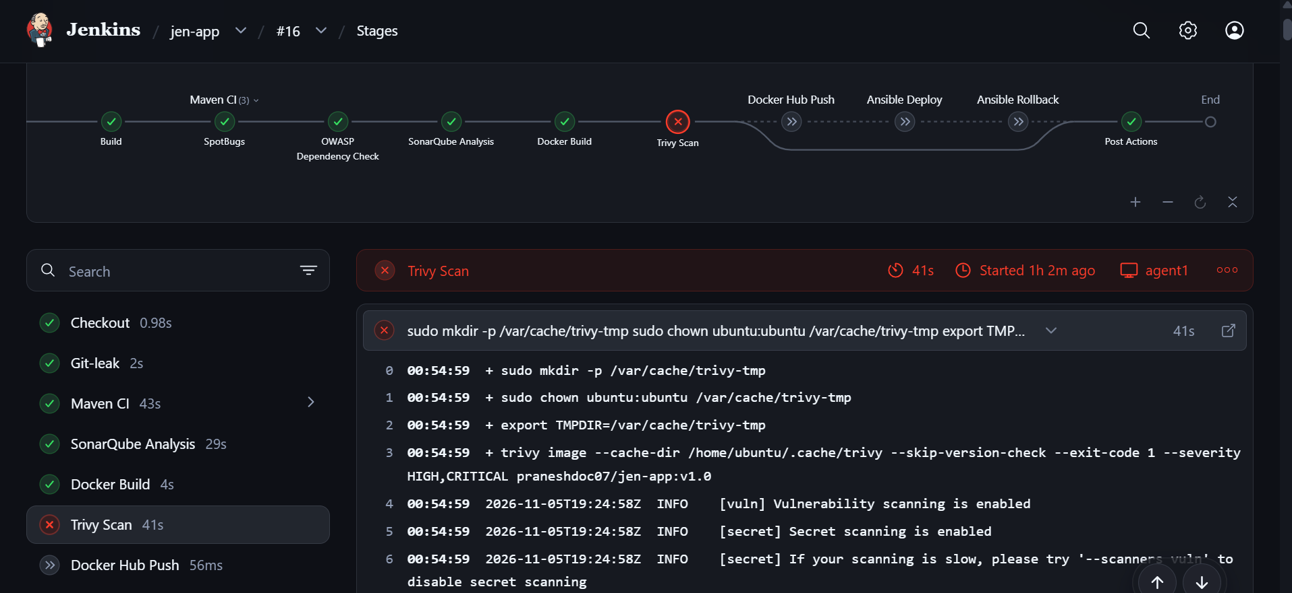
Pipeline error when any stages is failed

Succeed pipeline deploye the java image into the prod server and up and running through ansible:
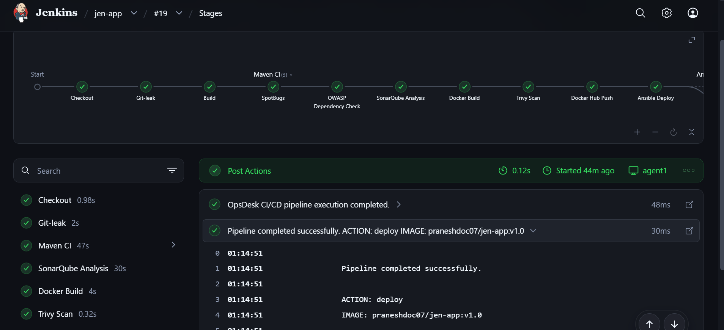

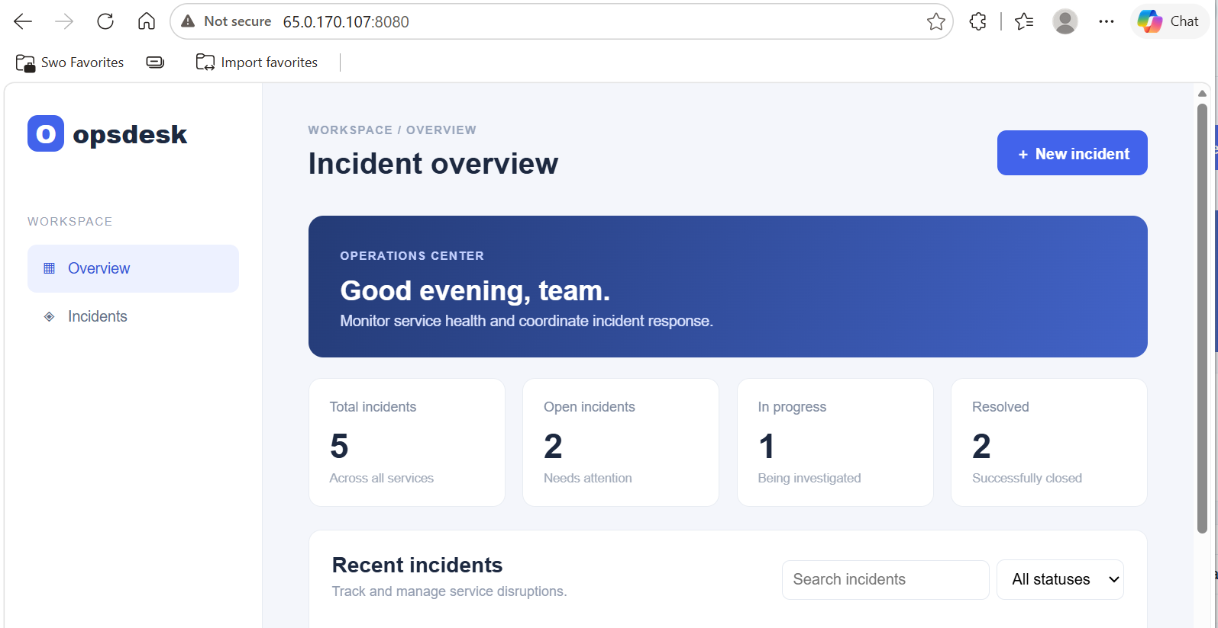

Now done a new version deployment with V1.1:
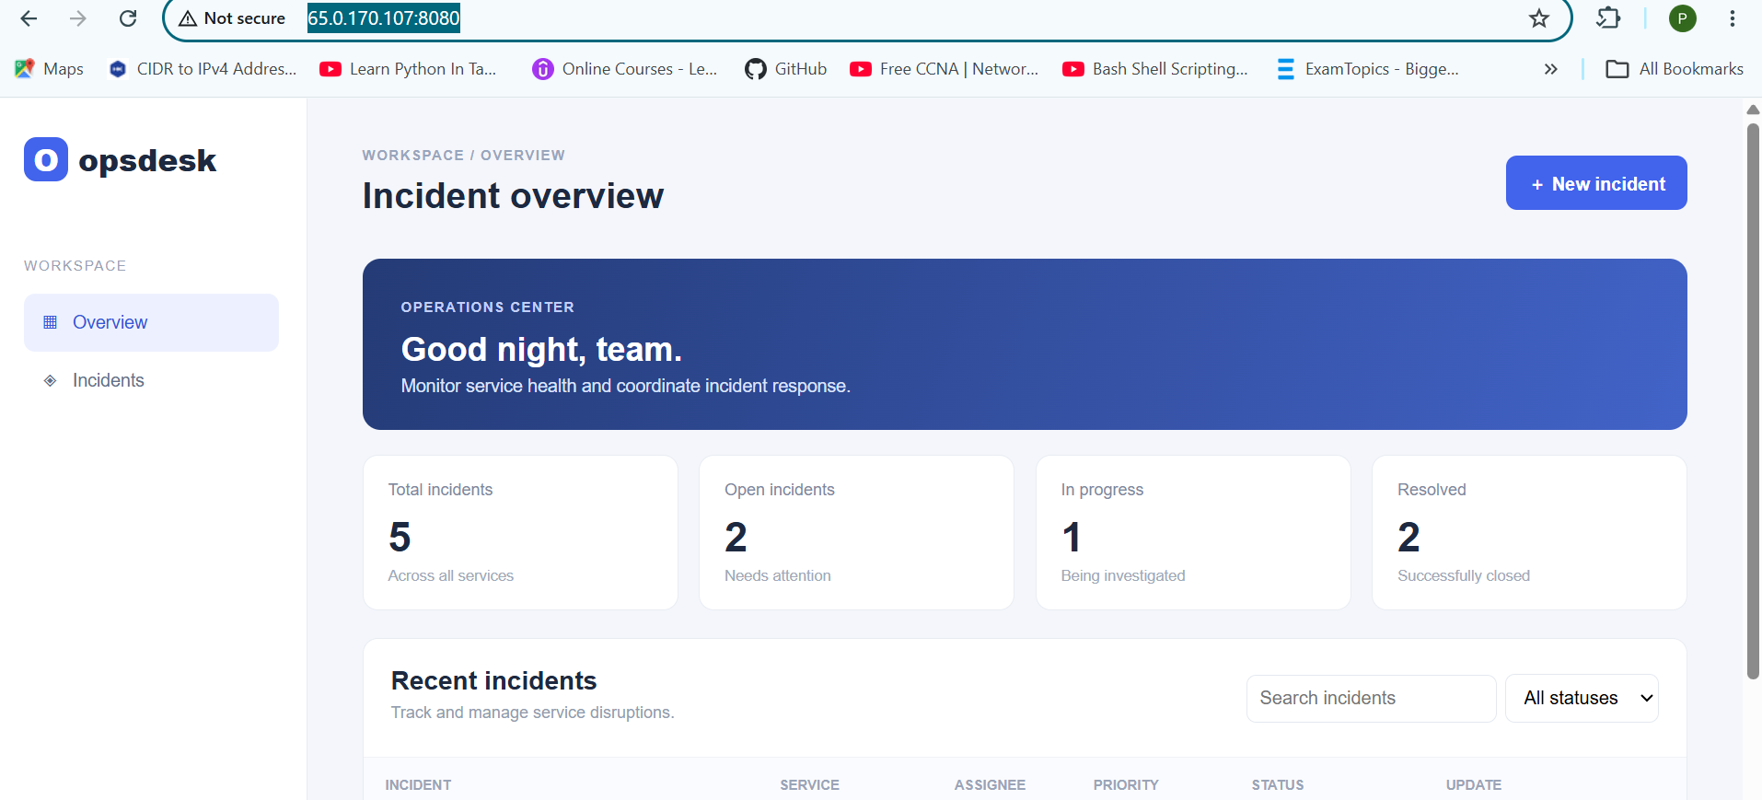
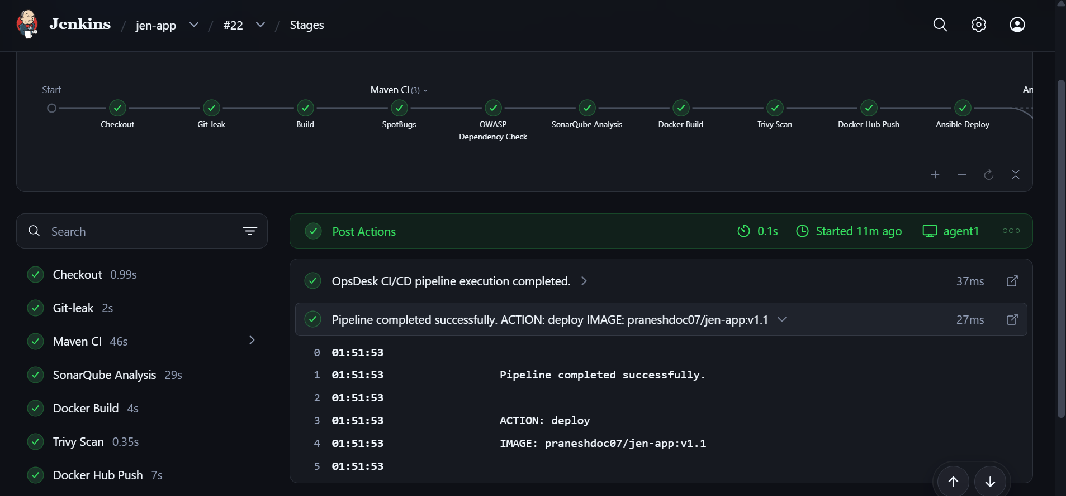
Now done a automatic rollback of when V1.1 deployed but health check failed in ansible it will lauch the container with previous image:
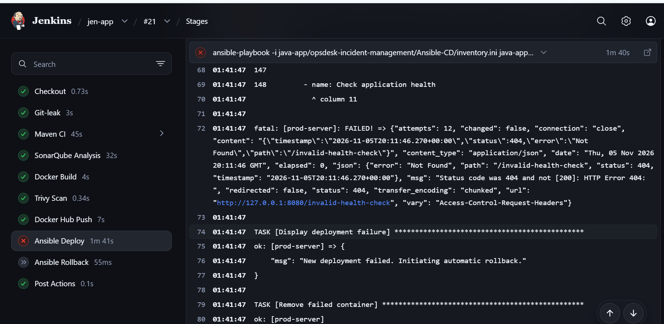
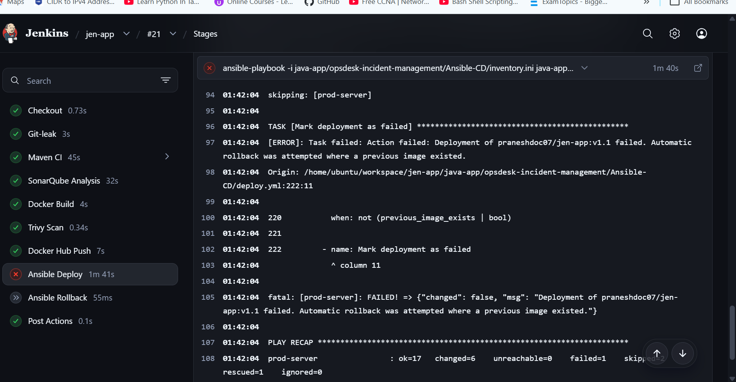

Manuall rollback if any Minor changes had issue in UI so manually giving parameter to use rollback and previous version:
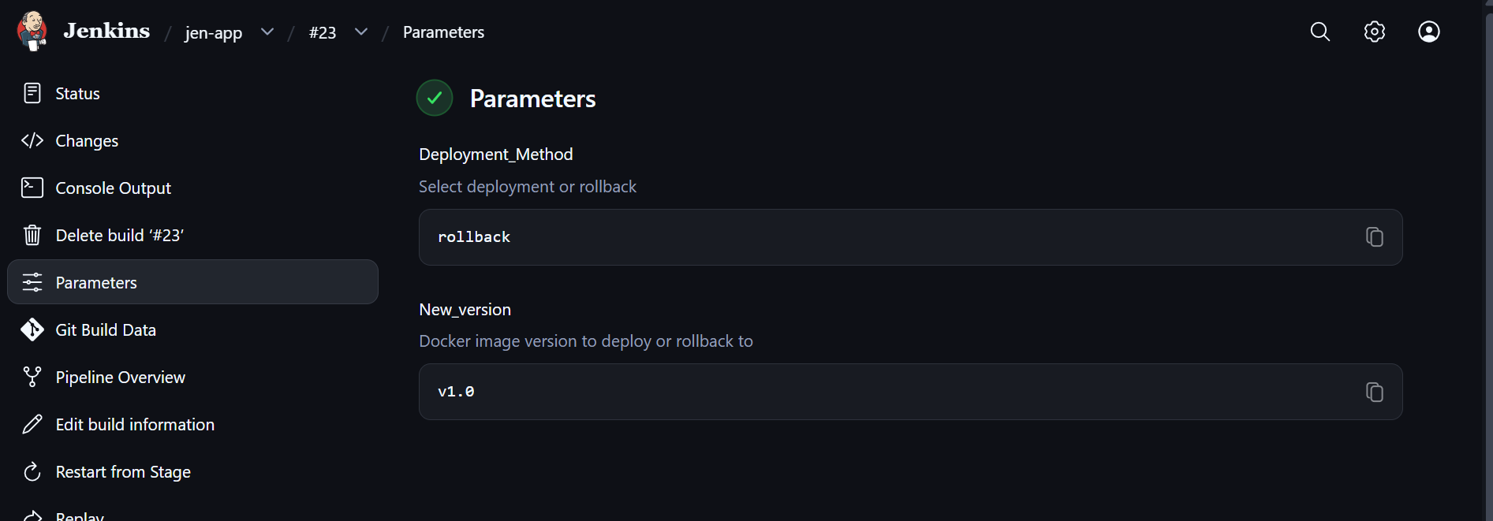

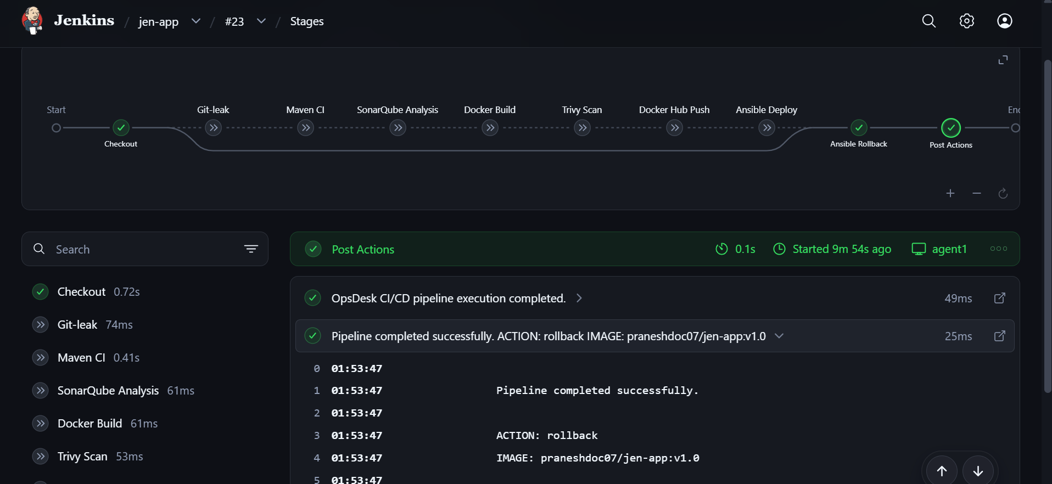

Build images in agent:


